Experiment No.5

**Write a shell script and C program to perform the following string operations:**

1. **To extract a substring from a given string.**

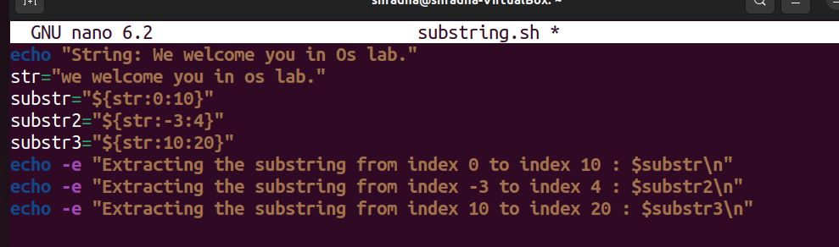

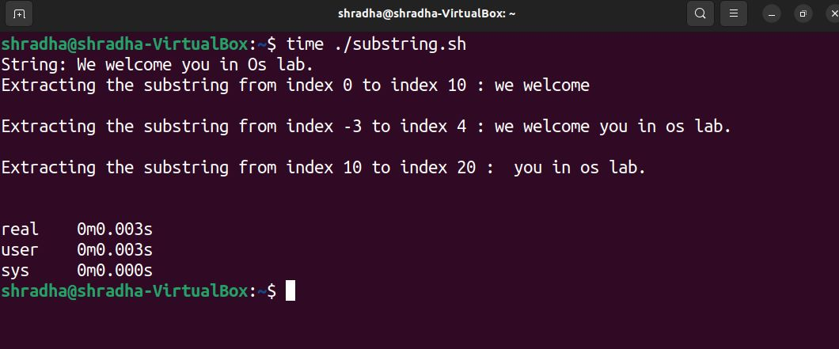

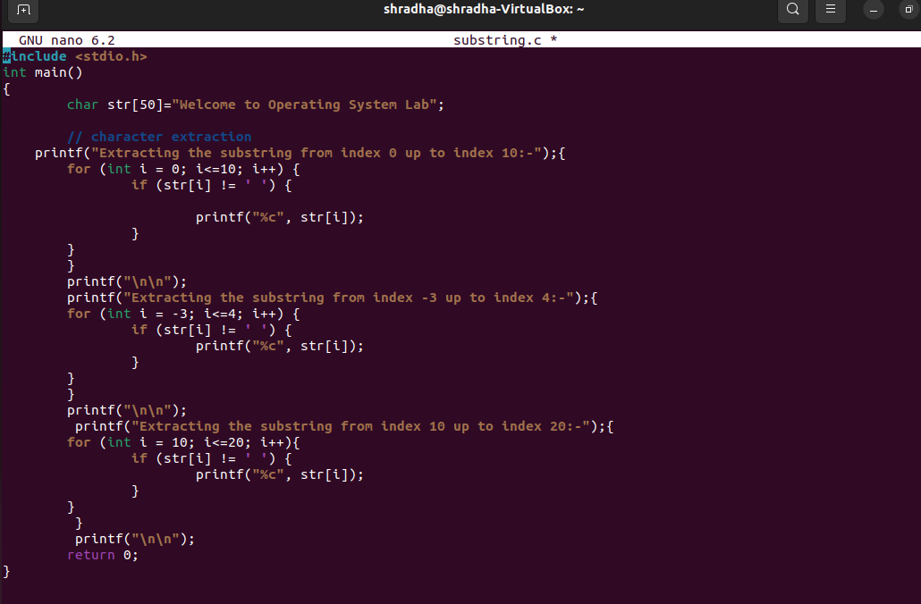

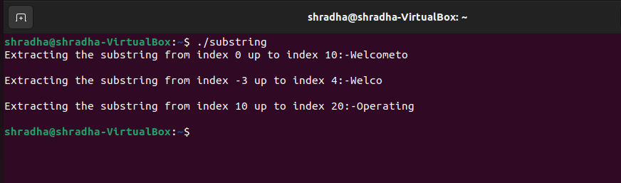

**b) To find the length of a given string.**

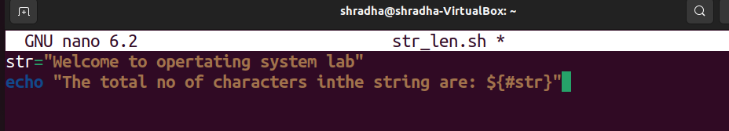

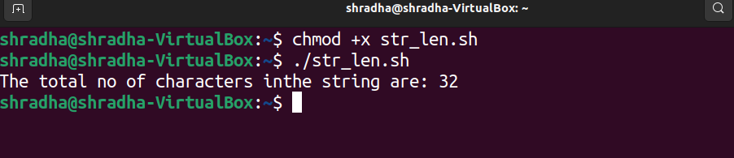

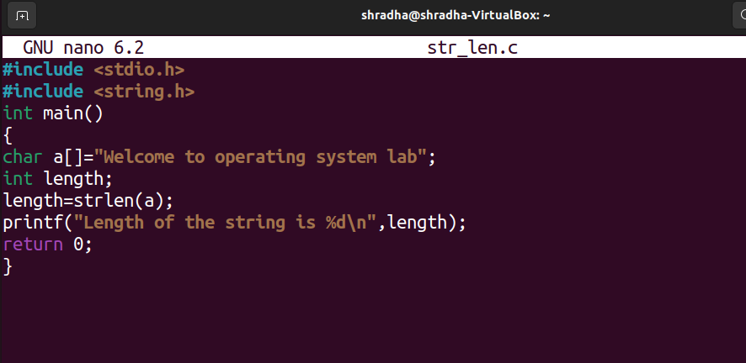

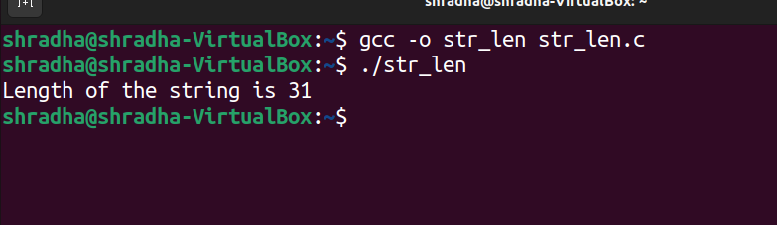

**Compare the running time of above shell script and C program using the time command.**



